# Java Web Development Basics

# Workshop: JSF

# Sboj.gb

**Sboj.gb** is an application for job offers. You have been tasked to implement this application for an unusually low price, by an unusually rich client. There are several requirements you must follow in the implementation.

## Database Requirements

The **Database** of the  application needs to support **2 entities**:

### User

* Has an Username
* Has a Password
* Has an Email

### Job Application

* Has a Sector
* Has a Profession
* Has a Salary
* Has a Description

Implement the entities with the **correct datatypes**, and implement **repositories** for them.

## Page Requirements

### Index Page (logged out user)

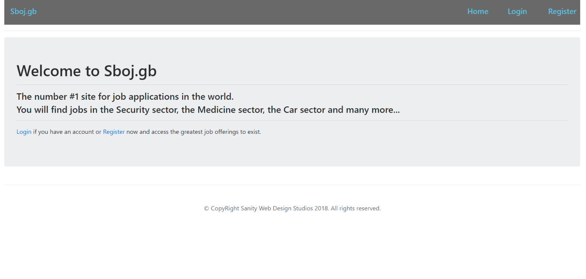

### Login Page (logged out user)

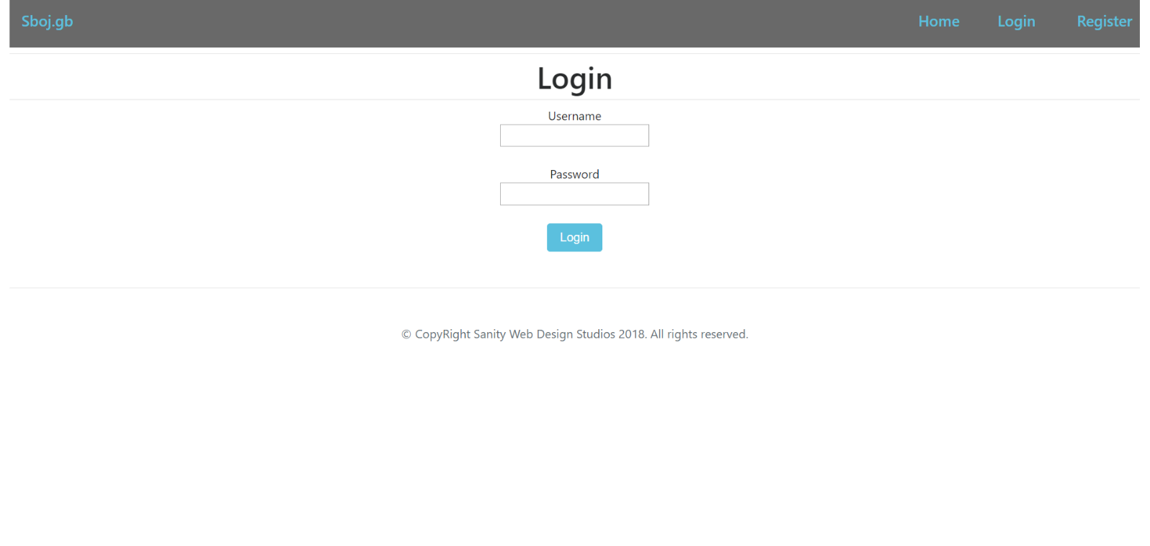

### Register Page (logged out user)

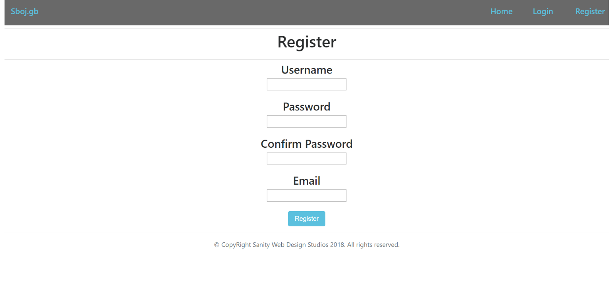

### Home Page (logged in user)

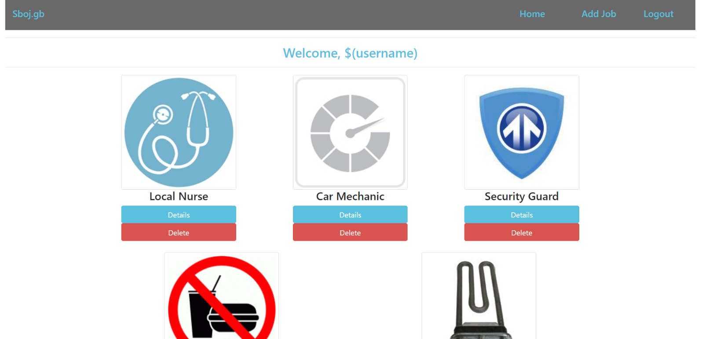

### Add Job Page (logged in user)

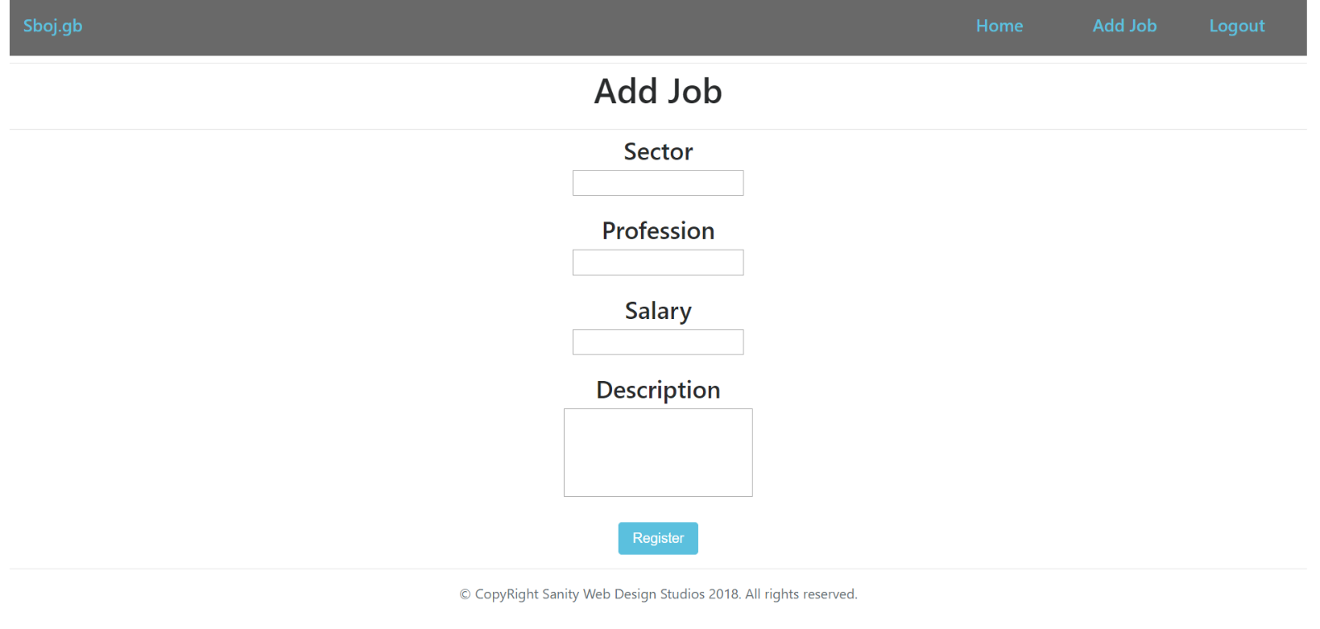

### Job Details Page (logged in user)

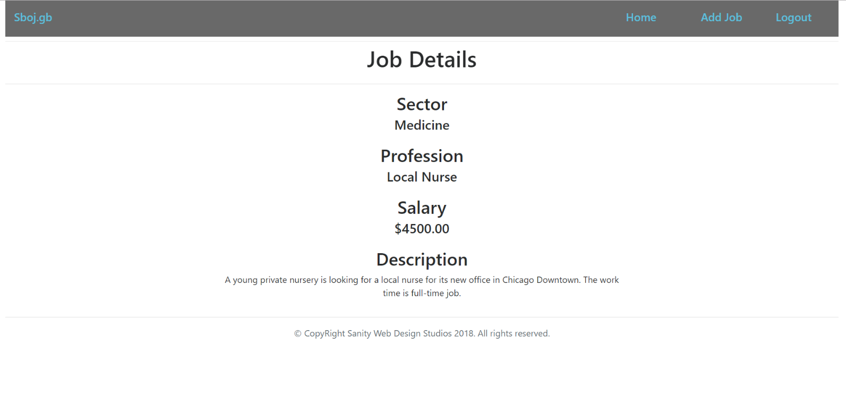

### Job Delete Page (logged in user)

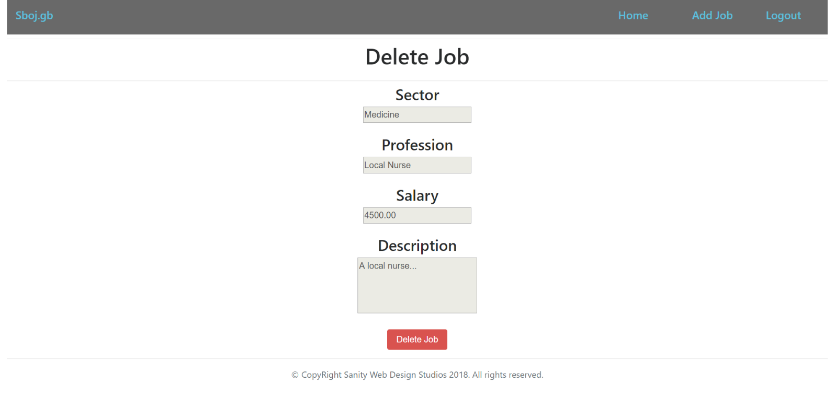

The templates have been given to you in the application skeleton, so make sure you implement the pages correctly.

**NOTE**: The templates should look **EXACTLY** as shown above.

**NOTE**: The templates do **NOT** **require** **additional** **CSS** for you to write. Only **bootstrap** and the **given css** are enough.

## Functional Requirements

The Functionality Requirements describe the functionality that the **Application** must support.

The **application** should provide Guest (not logged in) users with the functionality to login, register and **view** the Index page.

The **application** should provide Users (logged in) with the functionality to logout, **create** a Job, **view** **details** about a Job, **delete** a Job, and **view all** Jobs (Home page).

The **application** should provide **functionality** for **adding jobs** with **only** **5 sectors** – “Medicine”, “Car”, “Food”, “Domestic”, “Security”.

The **application** should **store** its **data** into a MySQL database, using Hibernate native.

## Security Requirements

The Security Requirements are mainly access requirements. Configurations about which users can access specific functionalities and pages.

* Guest (not logged in) users can access Index page.
* Guest (not logged in) users can access Login page.
* Guest (not logged in) users can access Register page.
* Users (logged in) can access Home page.
* Users (logged in) can access Job Details page.
* Users (logged in) can access Job Delete page.
* Users (logged in) can access Add Job page.
* Users (logged in) can access Logout functionality.